Git push

Backend Code pushed to git:

URL for git: <https://github.com/ManojGit1/Final-assessment>

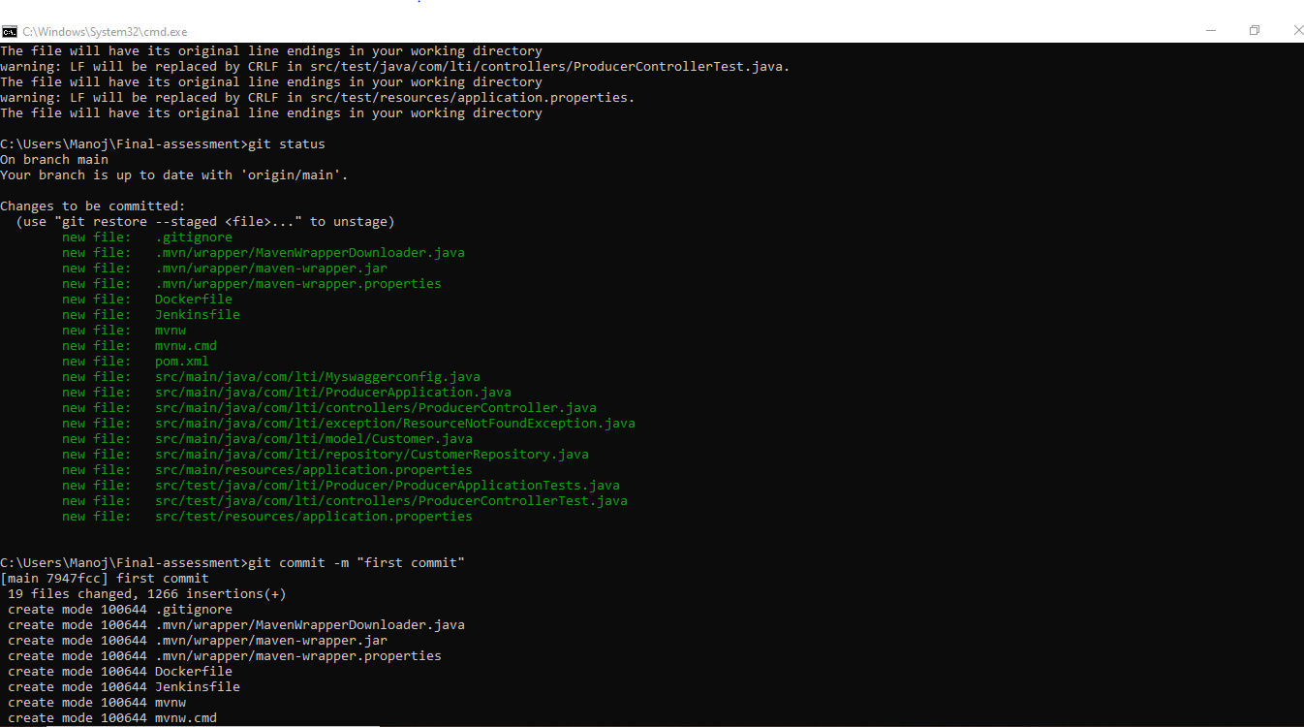

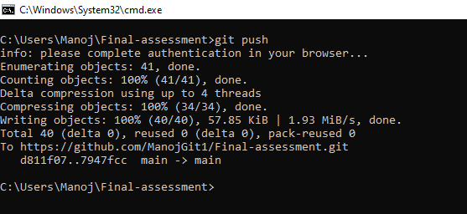

Frontend code pushed to git:

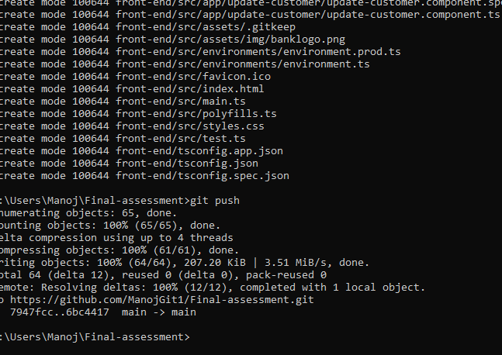

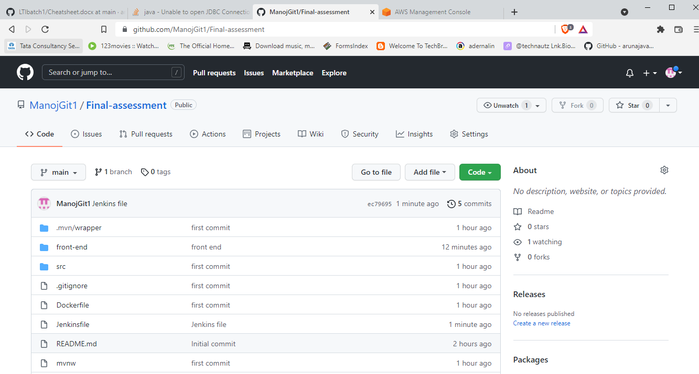

JUNIT TEST CASES AND COVERAGE:

Sonarlint:

Sonarqube:

Loggers:

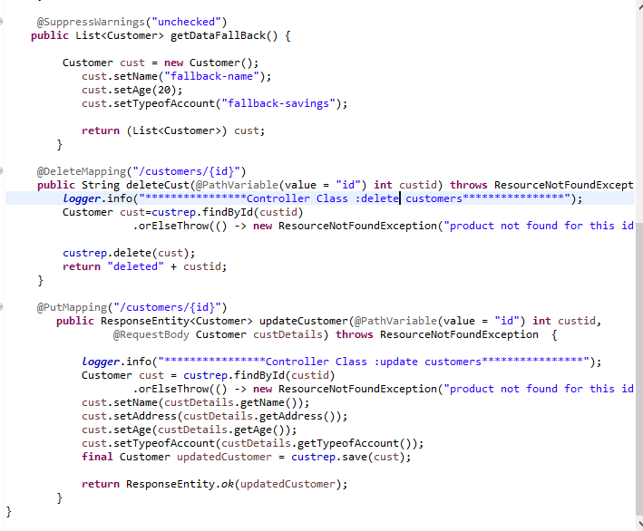

RDS INSTANCE:

EC2 Instance:

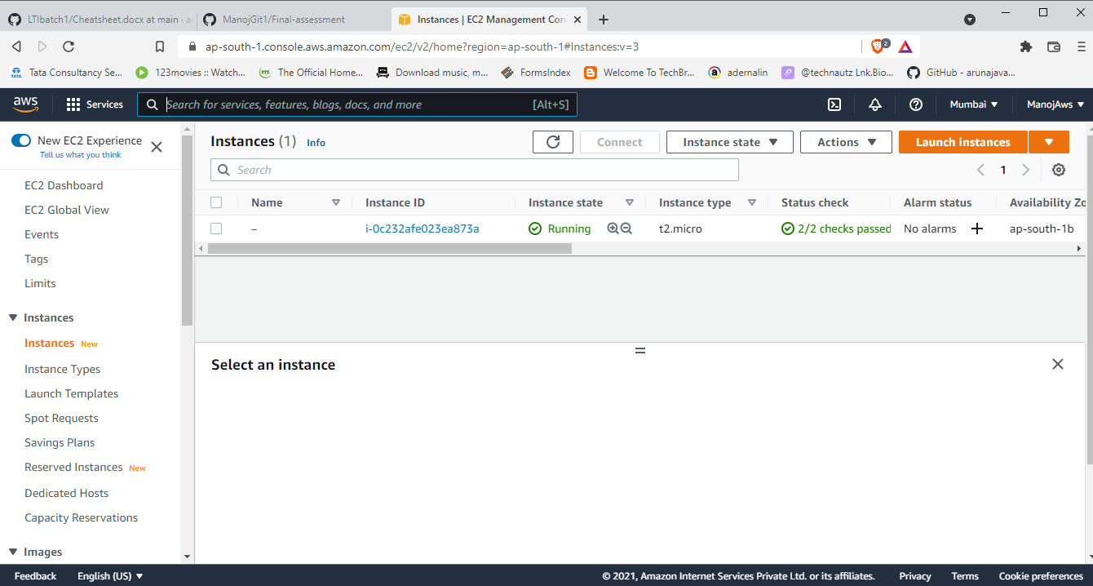

EC2 URL: <https://ec2-52-66-255-118.ap-south-1.compute.amazonaws.com>

S3 Instance:

S3 bucket: arn:aws:s3:::week4assessmentfrontend

JENKINS:

Docker:

